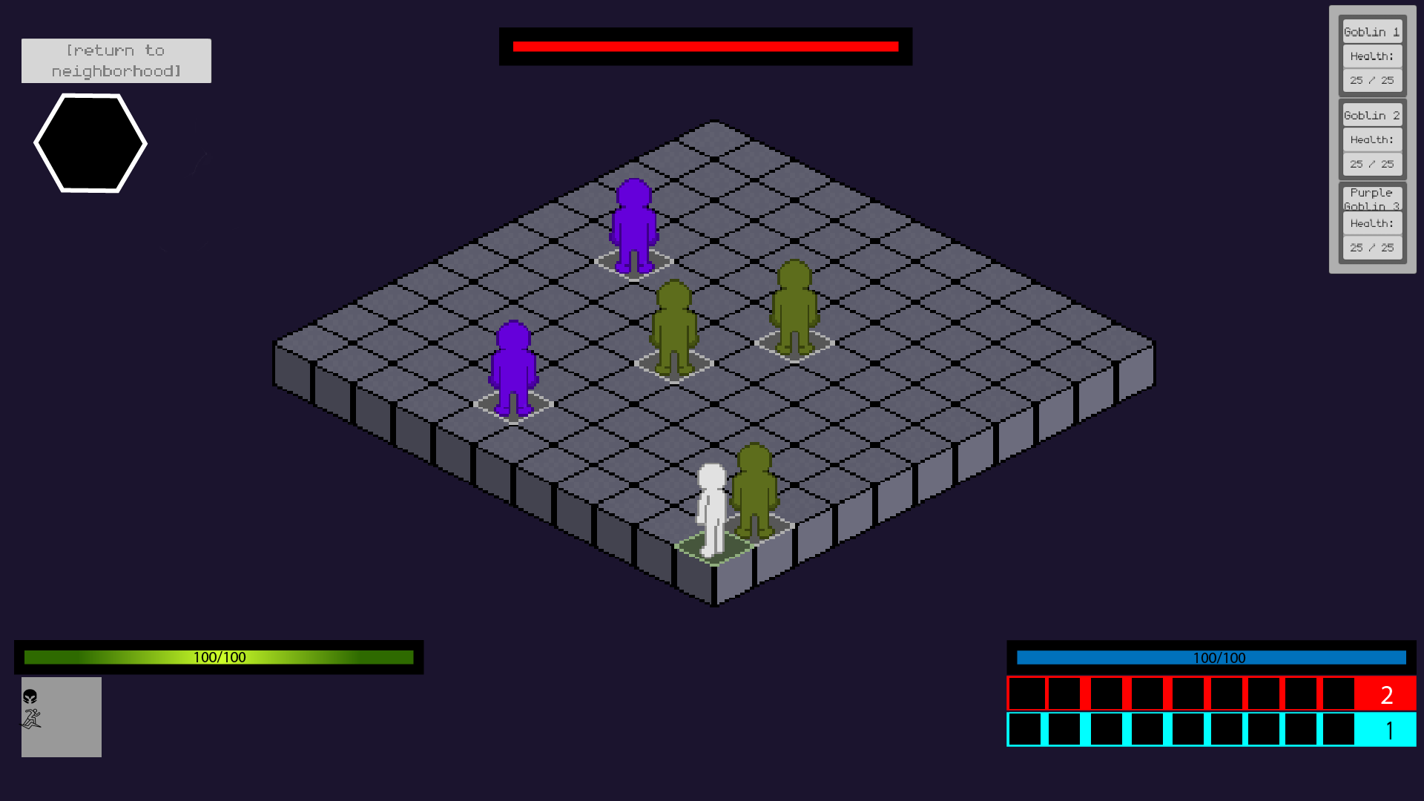

I had an idea to have a little part under the hp bar which can be toggled with a button such as C and this would allow you while in combat to see your miscellaneous stats with their corresponding icon such as stamina, armor, agility. League of legends has something similar to this.

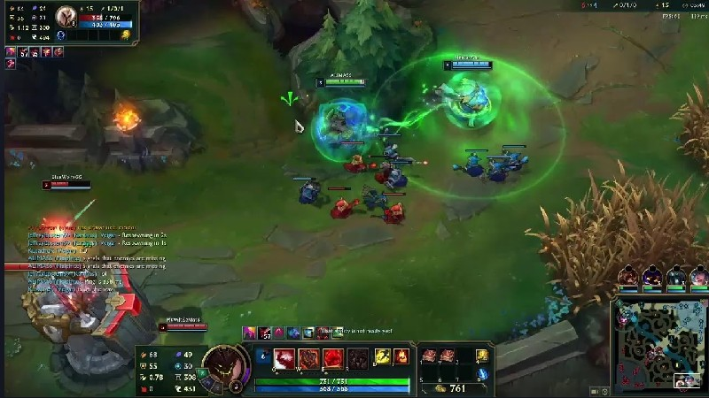

I was also thinking of keeping the small fodder enemies hp displayed like this or not this displayed at all but only keeping the main boss/the strongest enemy of the dungeon hp active.A video game with a pixelated figure

For the abilities I was thinking of inspiration from games like Dead cells, Ffxiv, Risk of Rain 2

and I had an idea of either being able to only use 1 type of attack style at a time for example if I switch to “keyboard 1” I am only allowed to use magic attacks and then “keyboard 2” would be physical attacks or abilites. Or just being able to use both is fine and 1 quickslot inventory would be made with the abilites corresponding to which ever binds are applied to them.

FFXIV DeadCells

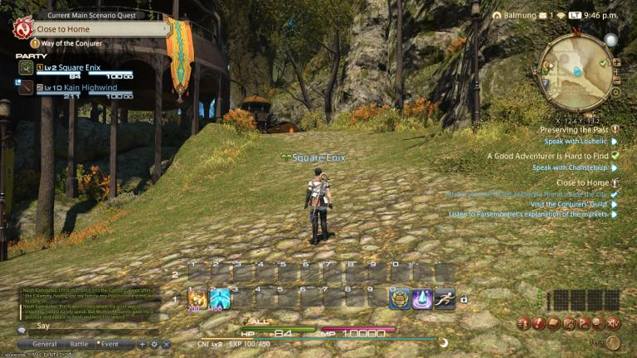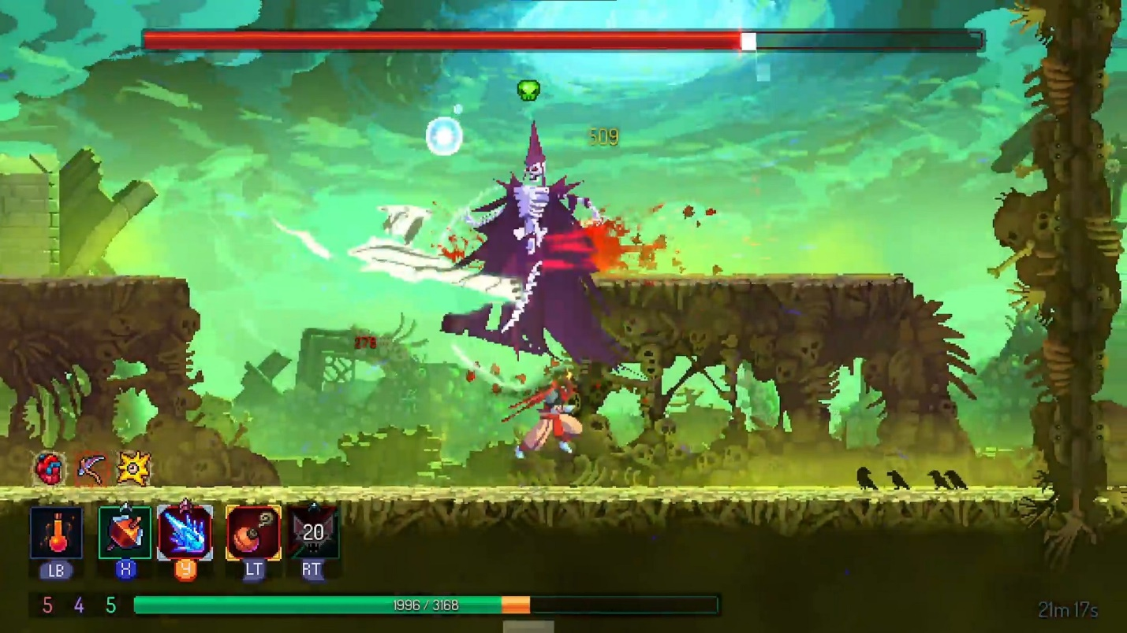

Risk Of Rain

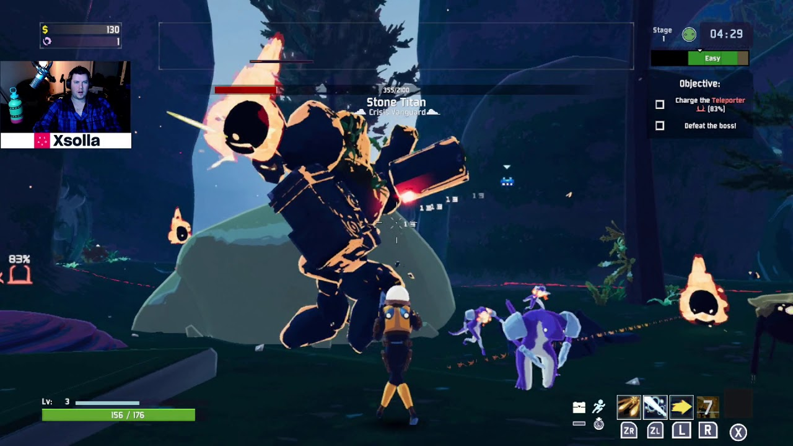

I was also thinking of adding a compass/mini map of the sort along side with the option of bailing on a dungeon.